

ISC 61

Welcome to Edinburgh

Welcome to the 61st International Submariners Congress here in Edinburgh Scotland It is also the 125th anniversary of submarines in Britian.

The 61st International Submariners Congress is a fantastic time to meet up with our friends and colleagues from all over the world, and is also a great time to meet new friends, but it is also a time to remember those people that can no longer be with us.

It is therefore a great honour and a privilege to hold another congress here in the UK, and to be host to such a large family of submariners from across the globe.

During your stay with us in May 2026, we have put together a wonderful package of exciting and interesting attractions that will make this congress a very memorable and enjoyable experience for everyone. We have included a varied program of events that include the sightseeing in Edinburgh, Sterling Castle, the Kelpies and the Falkirk wheel. Our last day will be a memorial service in Dundee

From myself, and all the members of the International Submariners Association (GB), we send out a very warm welcome to you all, and look forward to seeing you in May 2026.

Ian Vickers

President ISA(GB)

**Monday**

**Registration** Double Tree by Hilton

All trips will start at the Double Tree by Hilton

HOD’s meeting

Opening ceremony and exchange of gifts

**Tuesday**

**Edinburgh**

**City Sightseeing Edinburgh**

We will take the tram to the [Royal Yacht Britannia & Leith](https://edinburghtips.com/royal_yacht_brittania.html)

Where we will have time to visit the ship

Then you will have free time to explore Edinburgh

**PLACES OF INTEREST**

[Palace of Holyrood house](https://edinburghtips.com/holyroodhouse.html)

[Old Town & The Royal Mile](https://edinburghtips.com/old_town_royal_mile.html)

[The Scotch Whisky Experience](https://edinburghtips.com/scotch_whisky_experience.html)

[Camera Obscura & World of Illusions](https://edinburghtips.com/camera_obscura.html)

[Edinburgh New Town](https://edinburghtips.com/new_town.html) shops

[Monument to Sir Walter Scott](https://edinburghtips.com/scott_monument.html) and much more

**Wednesday**

Falkirk Wheel Kelpies and Stirling castle

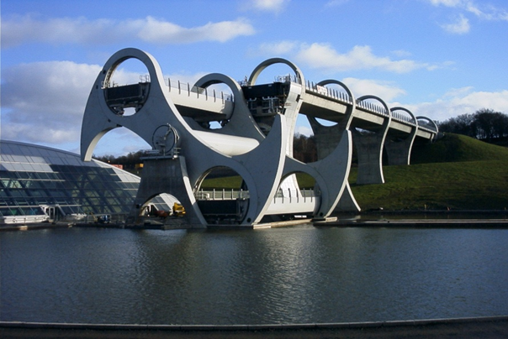

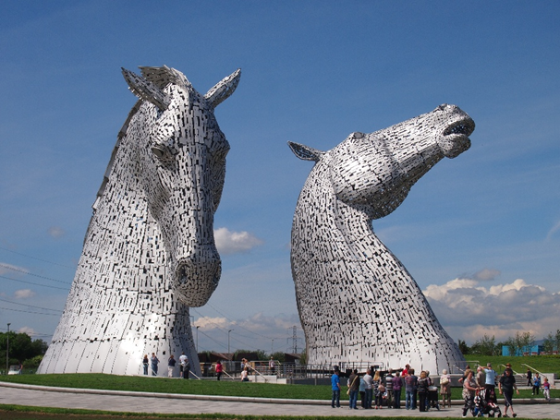

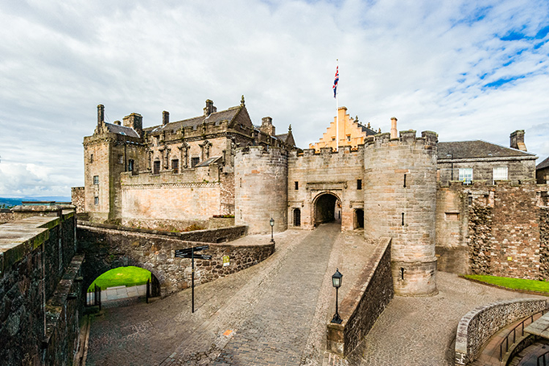

**Thursday**

Dundee and the Memorial Service at the Submariners Monument

It was proposed to have a talk by Dr. Andrew Jeffrey about the Submarine history at Dundee.

Possibly a reception at the city hall depending on numbers

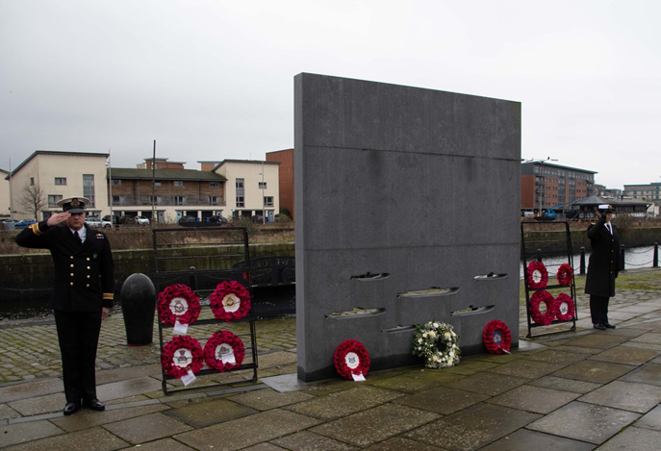

Heads of Delegation Meeting?

Gala night;

Scottish Dancers and Pipes and a band for the Dancing during the night.

Handover of the column

**Friday**

Fairwell

**Monday**

**Registration** Double Tree by Hilton

All trips will start at the Double Tree by Hilton

HOD’s meeting

Opening ceremony and exchange of gifts